**Characterization of *staphylococcus* species isolated from livestock, poultry and human**

**Md. Didarul Ahasan**

Department of Microbiology and Hygiene, **Bangladesh Agricultural University, Mymensingh**

**ABSTRCT**

The study was performed to characterize *Staphylococcus* spp. isolated from humans, livestock and poultry. A total of 100 samples were collected from humans (n=30), livestock (n=50) and poultry (n= 20). Samples were enriched in nutrient broth at 37 °C over night. Enriched cultures were streaked onto mannitol salt agar, nutrient agar and blood agar and incubated at 37 °C for 24 hrs for the isolation of bacteria in pure culture. Identification of bacteria were performed by cultural characteristics, staining and biochemical tests. The isolated *Staphylococcus* spp. were tested for antibiotic sensitivity against methicillin and vancomycin. A total of 58 Staphylococciwere isolated among them 33 were coagulase positive *Staphylococcus aureus* and 25 were other *Staphylococcus* spp. (CNS). Among the 33 coagulase positive *S. aureus* isolates, 17 (51.51%) produced golden, 9 (27.27%) produced yellow and 7 (21.21%) produced whitish pigments in mannitol salt agar media. A total of 25 (75.75%) *S. aureus* were β hemolysis producer on the blood agar media. Other *Staphylococcus* spp. were CNS and non-hemolytic. Antibiotic resistant pattern of the CPSA indicated two isolates of broilers and one isolate of cattle were resistant to methicillin but these isolates were sensitive to vancomycin. The results of this study suggested that MRSA is present in cattle and poultry which might constitute risk of transmission of MRSA to humans and other animals. More survey data are required to estimate the accurate prevalence of MRSA isolates in humans, livestock and poultry.

**INTRODUCTION**

*Staphylococcus* species are gram positive, nonmotile, nonspore forming, facultative anaerobic cocci occurring in pairs or irregular clusters similar to grapes (Ryan *et al*., 2004). The genus *Staphylococcus* has more than 20 species, most are harmless and reside normally on the [skin](http://en.wikipedia.org/wiki/Skin) and mucous membranes of human and other organisms (Madigan *et al.,* 2005). The most ubiquitous of these species is *Staphylococcus epidermidis* which is found on the skin of human and animals and rarely causes disease. *S. epidermidis* is one of five most common organisms that cause nosocomial infections due to the increase in usage of biomaterials in the clinical environment (Mack *et al.,* 2007). *Staphylococcus aureus* is the most common species of staphylococcus to cause Staph infections. The reason *S. aureus* is a successful pathogen is a combination of bacterial immune-evasive strategies. The growth of *S. aureus* in foods is a potential public safety hazard since many of its strains produce enterotoxins that cause food poisoning when ingested. *Staphylococcus intermedius* and *hyicus* have also been shown to produce enterotoxins in food. *Staphylococcus saprophyticus* is known only to cause urinary tract infections. The coagulase test is used to differentiate *Staphylococcus aureus* from the other species since it is the only one to produce the coagulase enzyme (Downes *et al.,* 2001, Holt *et al*., 2001, Doyle *et al*., 1994).

Antimicrobial resistance is a public health issue of growing concern. The use of antimicrobials can lead to the development of antimicrobial resistance in bacterial species (Tenover and McGowan, 1996; Acar and Rostel, 2001). Antimicrobial use in food animal production may become a public health issue when resistant organisms or their resistance genes spread from animals to humans by direct contact or through the food chain (Aarestrup, 2005; Wassenaar, 2005). The MRSA is currently causing a pandemic in hospitals around the world and is also emerging in the community (Chambers, 2001). Recently, MRSA has been identified in food production animals and people in contact with these animals (Voss *et al.,* 2005). The finding of this new zoonotic reservoir of MRSA has led to several research initiatives to investigate its implications. These studies strongly suggest that people working with livestock are at a potential risk of becoming MRSA carriers and hence are at an increased risk of infections caused by MRSA. To date, there is no comprehensive data on the situation of MRSA in Bangladesh. The aim of this study was to evaluate the occurrence of MRSA in people in contact with livestock, in farm animals, and in food of animal origin, and to investigate phenotypic resistance data of isolated strains.

To prevent the occurrence of disease in humans, it is important to investigate the transmission routes from animals to humans and from humans to humans as well. The role of MRSA as a food pathogen needs more research. Microbiologists should investigate the pathogenicity and the capacity for transmission between humans of this particular novel strain to assess the potential threat for public health. At the same time, cooperation between epidemiologists and microbiologists in the human and veterinary field will be required to create a complete overview of all aspects of this problem and to develop cost-effective prevention strategies in both the human and animal populations. Considering the above problems the present research work was undertaken to determine the prevalence of *Staphylococcus* spp. in various samples of human and animals with characterization of *Staphylococcus* spp and their antimicrobial sensitivity profiles against methicillin and vancomycin.

**MATERIALS AND METHODS**

**Study area**

The study was conducted in the laboratory of the Department of Microbiology and Hygiene, Bangladesh Agricultural University (BAU), Mymensingh during the period from January 2012 to June 2012.

**Sources of samples**

A total of 100 samples were collected from humans (n=30), livestock (n=50) and poultry (n= 20) with proper aseptic precautions.

In case of livestock, a total of 30 nasal swabs viz. 10 slaughter cattle, 10 dairy cattle and 10 breeding goat were collected from slaughter house of Mymensingh, BAU dairy farm and goat farm respectively. Ten abscess samples viz. 5 cattle and 5 goat/sheep from BAU veterinary clinic were collected aseptically for the study. For assessment the MRSA contaminated meat, 10 samples were collected from local market, Mymensingh. The samples was collected with proper aseptic precaution and carried to the laboratory for inoculation into culture media with specific identification marks.

In case of Human, a total of 30 nasal swabs viz. 10 slaughter employees, 10 dairy farm workers and 10 goat breeding farm workers were collected from slaughter house of Mymensingh, BAU dairy farm and goat breeding farm respectively. Immediately after collection the swab sticks were put into sterile test tubes and carried to the laboratory for inoculation into culture media with specific identification marks.

**Media for culture**

**~~Liquid media (broth)~~**

~~The liquid media used in the study were Nutrient broth (NB) and Sugar media.~~

**~~Agar media~~**

~~Nutrient agar (NA), Mannitol Salt agar (MSA), Blood agar (BA) and Muller Hington agar (MHA) were used for this study.~~

**~~Chemicals and reagents~~**

~~The chemicals and reagents used for the study were Phosphate buffered saline (PBS) solution, reagents for Gram’s staining (Crystal violet, Gram’s iodine, , Acetone alcohol and Safranin), 3% Hydrogen peroxide, Normal saline solution, Rabbit plasma, 80% glycerin, Alcohol and other common laboratory chemicals and reagents.~~

**Antibiotic disc**

The test was performed using disc diffusion method. Commercially available antibiotic discs (Oxoid, England) were used for the test to determine the drug sensitivity pattern. This method allowed for the rapid determination of the efficacy of the drugs by measuring the diameter of the zone of inhibition that resulted from different diffusion of the agent into the medium surrounding the disc (Monica Chessbrough, 1985).

**Brief description of the experimental design**

The experimental design is schematically presented in Figure 1. The entire study was divided into three major steps: The first step included collection of samples from different areas, their transportation to the laboratory and inoculation into nutrient agar, blood agar and mannitol salt agar. In the second step isolation and identification of the *Staphylococcus spp.* was done on their cultural character including pigment production, haemolytic activity, Gram’s staining character and catalase activity. In the third step characterization of the organism was done using coagulase test and basic sugar fermentation test. Finally their antibiotic sensitivity test was also performed.

**Collection and transportation of samples**

A total of 100 samples were collected from humans (n=30), livestock (n=50) and poultry (n= 20) with proper aseptic precautions. Nasal swabs, pus, tracheal and clocal swab were collected with sterile swab stick. In case of meat, pieces of meat was collected in sterilized petridishes and brought to the laboratory (Department of Microbiology) with necessary precaution for bacteriological examination. All the samples labeled. The samples were placed in nutrient broth. After 24 hours incubation at 37 oC, each plate was examined for the identification of organisms.

**Hemolytic activity**

Haemolytic activities of *S. aureus* were observed as per the method described by Chartterjee *et al.,* (1990). All the strains were tested for the production of alpha (α) and beta (β) haemolysis by growing them on bovine BA plates and were then incubated at 370 C for 24 hours to determine their hemolytic property. The colony developed on the BA was examined for various types of hemolysis. The hemolytic pattern of the bacteria was categorized according to the types of hemolysis produced on BA plates (Alpha (α) hemolysis: a zone of greenish discoloration around the colony manifested by partial hemolysis. Beta (β) hemolysis: complete clear zone of hemolysis around the colony: Gamma (γ) hemolysis: no detectable hemolysis).

**Biochemical tests**

Sugar fermentation test,Indole and MR-VP test,catalase test, coagulase test according to the procedure described by Cowan (1985). Test for pigment production was performed according to the procedures described by Chatterjee *et al*., (1990).

**Isolation and identification of *Staphylococcus* spp**

For the isolation and identification of bacterial flora, the procedure suggested by (Carter, 1979) was followed throughout the experiment. Isolation of *Staphylococcus* spp. from the collected samples was made by inoculating the samples on NA, BA and MSA. The inoculated media were then incubated aerobically at 37° C for 24 hours for growth. The isolates were identified on Staphylococcus based on their morphology and cultural characteristics and biochemical characters (Ellner 1978). The coagulase test was performed for the identification of the pathogenic *Staphylococcus aureus* from non-pathogenic ones. All the coagulase positive staphylococcal strains were further tested for pigment production, haemolysis on nutrient and blood agar, respectively. Stock culture was prepared and maintained for subsequent studies.

**Test for isolation between *Staphylococcus aureus* and other *Staphylococcus* spp.**

To differentiate between *Staphylococcus aureus* and other *Staphylococcus* spp. it was considered the hemolysis, pigment production and coagulase test.

**Antibiotic sensitivity test**

Staphylococci were tested for antimicrobial drug susceptibility against 02 commonly used antibiotics belonging to different groups by disc diffusion method or Kirby-Bauer method (Bauer *et al.,* 1966). The antibiogram of isolates (*Staphylococcus* spp.) were determined on freshly prepared, dried up Mueller Hinton agar using by the Kirby-Bauer Disc Diffusion Method (Bauer *et al.,* 1966) according to Clinical and Laboratory Standards Institute (CLSI, formerly NCCLS, 2007) procedures. The tested antibiotics included: Methicillin (5 μg/ disc), Vancomycin (30 μg/ disc), (Oxoid, England).

Based on zones of inhibition, interpreted using the criteria recommended for by CLSI (2007), isolates were classified as either sensitive (S), Intermediate (I) or resistant (R). The isolates resistant to three or more antibiotics were classified as multi-drug resistant (MDR) strains.

Antimicrobial agents with their disc concentrations and zone diameter interpretive standards for *Staphylococcus* spp. are presented in Table 2.

Table 2

Antimicrobial agents with their disc concentrations and zone diameter interpretive standards for *Staphylococcus aureus* and other *Staphylococcus* spp. by CLSI (2007).

|  |  |  |  |  |  |
| --- | --- | --- | --- | --- | --- |
| Antimicrobial agents | Symbol | Disc concentration | zone diameter (mm)interpretive standards | | |
| R | I | S |
| Methicillin | MET | 5 µg | ≤9 | 10-13 | ≥14 |
| Vancomycin | VA | 30 µg | - | - | ≥15 |

**Turbidity standard for inoculums preparation**

To standardize the inoculum density for a susceptibility test, a BaSO4 turbidity standard, equivalent to a 0.5 McFarland standard or its optical equivalent (e.g., latex particle suspension) were used.

**Sterile buffered glycerine (20%) method**

20% of pure glycerine and 80 parts of PBS were mixed to make 20% sterile buffered glycerine. A loop full of thick bacterial culture was mixed with 20% sterile buffered glycerine in small vials and preserved at -200 C. By this method bacteria can be preserved with no deviation of their original characters for several years (Buxton and Fraser, 1977).

RESULTS

**Results of cultural examination**

Out of 100 samples, 58 samples were tested positive for *Staphylococcus* spp. (Table 3). On the basis of cultural characteristics 33 isolates were characterized as *S. aureus* and rest 25 isolates were other *Staphylococcus* spp. The summary of the results of cultural examination of *Staphylococcus* spp.in different cultural media is presented in Table 4.

**Table 3.** Results of isolation of *Staphylococcus* spp.from samples of human, livestock and poultry.

|  |  |  |  |  |
| --- | --- | --- | --- | --- |
| **Source of samples** | | **Name of samples** | **No. of samples examined** | **No. of positive isolates**  **n (%)** |
| **Human** | Slaughter employees | Nasal swab | 10 | 6 (60) |
| Cattle farm workers | Nasal swab | 10 | 5 (50) |
| Goat farm workers | Nasal swab | 10 | 3 (30) |
| **Livestock** | Cattle(Slaughter house) | Nasal swab | 10 | 6 (60) |
| Cattle(Dairy farm) | Nasal swab | 10 | 6 (60) |
| Goat (Goat farm) | Nasal swab | 10 | 5 (50) |
| **Poultry** | Broiler | Nasal swab | 5 | 4 (80) |
| Cloacal Swab | 5 | 2 (40) |
| Layer | Nasal swab | 5 | 3 (60) |
| Cloacal Swab | 5 | 1 (20) |
| **Diseased animals** | Cattle | Abscess | 5 | 5 (100) |
| Goat | Abscess | 5 | 5 (100) |
| **Market meat** | Cattle | Beef | 5 | 4 (80) |
| Goat | Chevon | 5 | 3 (60) |

**4.1.1 Nutrient broth**

The growth of Staphylococci in NB was characterized by diffused turbidity and in few occasions pellicle was seen.

**4.1.2 Nutrient agar**

Small, circular and smooth raised gray white or yellowish colonies in *S. aureus* (Fig. 1) and white colonies in other *Staphylococcus* spp. (Fig. 3) were observed on nutrient agar media.

**4.1.3 Mannitol salt agar**

Staphylococci showed different colonies on the mannitol salt agar (MSA). *S. aureus* fermented MSA with the production of yellowish colonies (Fig. 2). On the other hand, Whitish colonies without fermentation of MSA indicated the growth of other *Staphylococcus* spp. (Fig. 4).

**4.1.4 Blood agar**

Colonies *of Staphylococcus* spp. on blood agar media were circular, small, smooth raised with gray white or yellowish in color. No hemolysis was noticed in case of other *Staphylococcus* spp. (Fig. 9) but β-hemolysis was seen for *S. aureus* on BA media (Fig. 8).

**4.2 Results of microscopic examination**

**4.2.1 Gram's Staining**

Staphylococci were gram posotive, cocci and arranged in grapes like cluster (Fig. 5).

**Table 4.** Summary of cultural characteristics of *Staphylococcus* spp. isolated from human, livestock and poultry.

|  |  |  |  |  |
| --- | --- | --- | --- | --- |
| **Sl. No.** | **Colony characteristics on** | | | **Interpretation** |
| **Nutrient agar** | **Mannitol salt agar** | **Blood agar** |
| **1.** | Small, circular, smooth raised gray white colonies. | Small, circular, whitish colonies without fermentation. | Small, circular, smooth raised gray white colonies without hemolysis. | Coagulase negative *Staphylococcus* spp. |
| **2.** | Small, circular, smooth raised yellowish colonies. | Small, circular yellowish colonies with fermentation. | Small, circular, smooth raised yellowish colonies with β hemolysis. | *S. aureus* |

**4.3 Results of biochemical test**

**4.3.1 Results of fermentation reaction with five basic sugars**

All the isolates fermented dextrose, maltose, lactose, sucrose and mannitol and produced only acid. Acid production was indicated by the color change from reddish to yellow (Fig. 10).

**4.3.2 Results of catalase test**

Catalase test was performed to differentiate Staphylococci (catalase producer) from Streptococci (non-catalase producer). Hydrogen peroxide was breakdown into water and oxygen. Production of oxygen was indicated by the bubble formation (Fig. 6). All *Staphylococcus* isolates were catalase positive.

**4.3.3 Results of Coagulase test**

A total of 33 *Staphylococci* isolates gave positive reaction in coagulase test indicated that they were *S. aureus* (Fig. 7A). On the other hand 25 isolates were found to be coagulase negative which were other *Staphylococcus* spp. (Fig. 7B). The summary of coagulase positive and negative *Staphylococcus* spp*.* isolated from humans, livestock and poultry samples are listed in Table 5.

**Table 5.** Summary of the results of coagulase test of *Staphylococcus* spp. isolated from human, livestock and poultry.

|  |  |  |  |  |  |
| --- | --- | --- | --- | --- | --- |
| **Source of samples** | | **Name of samples**  **(n)** | **No. of Staphylococcipositive isolates** | **No. of coagulase positive isolates n**  **(%)** | **No. of coagulase negative isolates**  **n**  **(%)** |
| **Human** | Slaughter employees | Nasal swab  (10) | 6 | 3  (50) | 3  (50) |
| Cattle farm workers | Nasal swab (10) | 5 | 2  (40) | 3  (60) |
| Goat farm workers | Nasal swab (10) | 3 | 1  (33.33) | 2  (66.67) |
| **Livestock** | Cattle  (Slaughter house) | Nasal swab (10) | 6 | 4  (66.67) | 2  (33.33) |
| Cattle  (Dairy Farm) | Nasal swab (10) | 6 | 3  (50) | 3  (50) |
| Goat  (Goat farm) | Nasal swab (10) | 5 | 2  (40) | 3  (60) |
| **Poultry** | Broiler | Nasal swab  (5) | 4 | 3  (75) | 1  (25) |
| Cloacal swab  (5) | 2 | 1  (50) | 1  (50) |
| Layer | Nasal swab  (5) | 3 | 2  (66.67) | 1  (33.33) |
| Cloacal swab (5) | 1 | 1  (100) | 0  (0) |
| **Diseased animals** | Cattle | Abscess lesion  (5) | 5 | 4  (80) | 1  (20) |
| Goat | Abscess lesion  (5) | 5 | 4  (80) | 1  (20) |
| **Market meat** | Cattle | Beef  (5) | 4 | 2  (50) | 2  (50) |
| Goat | Chevon  (5) | 3 | 1  (33.33) | 2  (66.67) |

**4.3.4 Results of pigment production and haemolytic activity.**

The summary of production of different types pigment by coagulase positive *Staphylococcus aureus* on mannitol salt agar and production of β hemolysis on blood agar media is presented in Table 6.

**Table 6.** Summary of results of pigment production and β hemolysis of coagulase positive *Staphylococcus* spp.isolates of humans, livestock and poultry

|  |  |  |  |  |  |  |
| --- | --- | --- | --- | --- | --- | --- |
| **Source of samples** | | **Number of coagulase positive isolates** | **Pigment production** | | | **β-Haemolysis production**  **n**  **(%)** |
| **Golden yellow**  **n (%)** | **Yellow**  **n**  **(%)** | **Whitish**  **n**  **(%)** |
| **Human** | Slaughter employees | 3 | 2  (66.67) | 1  (33.33) | 0  (0) | 2  (66.67) |
| Cattle farm workers | 2 | 1  (50) | 0  (0) | 1  (50) | 1  (50) |
| Goat farm workers | 1 | 1  (100) | 0  (0) | 0  (0) | 1  (100) |
| **Livestock** | Cattle  (Slaughter house) | 4 | 2  (50) | 1  (20) | 1  (20) | 3  (75) |
| Cattle(Dairy Farm) | 3 | 2  (66.67) | 1  (20) | 0  (0) | 3  (100) |
| Goat  (Goat farm) | 2 | 1  (50) | 0  (0) | 1  (50) | 1  (50) |
| **Poultry** | Broiler | 3 | 2  (66.67) | 1  (33.33) | 0  (0) | 2  (66.67) |
| 1 | 0  (0) | 0  (0) | 1  (100) | 0  (0) |
| Layer | 2 | 0  (0) | 1  (50) | 1  (50) | 1  (50) |
| 1 | 0  (0) | 0  (0) | 1  (100) | 0  (0) |
| **Diseased animals** | Cattle | 4 | 3  (75) | 1  (25) | 0  (0) | 4  (100) |
| Goat | 4 | 2  (50) | 1  (25) | 1  (25) | 4  (100) |
| **Market meat** | Cattle | 2 | 1  (50) | 1  (50) | 0  (0) | 2  (100) |
| Goat | 1 | 0  (0) | 1  (100) | 0  (0) | 1  (100) |

**4. 4 Antibiotic sensitivity profiles**

Out of 33 caogulase positive *Staphylococcus aureus* (CPSA) 30 were found to be sensitive to methicillin. Three CPSA isolates were found to be methicillin resistant of which 2 were isolated from broiler and 1 from the cattle. On the other hand, all of the CPSA isolates were sensitive to vancomycin. The detail results are shown in Table 7.

**Table 7.** Antimicrobial profiles of coagulase positive *Staphylococcus aureus* isolated from human, livestock and poultry against methicillin and vancomycin.

|  |  |  |  |  |  |  |  |  |
| --- | --- | --- | --- | --- | --- | --- | --- | --- |
| **Source of samples** | | **No. of coagulase positive isolates** | **No. of organisms found resistance** | | | | | |
| **Methicillin** | | | **Vancomycin** | | |
| **R** | **I** | **S** | **R** | **I** | **S** |
| **Human** | Slaughter employees | 3 | - | - | 3 | - | - | 3 |
| Cattle farm workers | 2 | - | - | 2 | - | - | 2 |
| Goat farm workers | 1 | - | - | 1 | - | - | 1 |
| **Livestock** | Cattle  (Slaughter house) | 4 | - | - | 5 | - | - | 5 |
| Cattle(Dairy Farm) | 3 | - | - | 4 | - | - | 4 |
| Goat  (Goat farm) | 2 | - | - | 2 | - | - | 2 |
| **Poultry** | Broiler | 3 | 2 | - | 1 | - | - | 3 |
| 1 |  |  |  |  |  |  |
| Layer | 2 | - | - | 2 |  |  |  |
| 1 | - | - | 1 |  |  |  |
| **Diseased animals** | Cattle | 4 | 1 | - | 3 | - | - | 4 |
| Goat | 4 | - | - | 4 | - | - | 4 |
| **Market meat** | Cattle | 2 | - | - | 2 | - | - | 2 |
| Goat | 1 | - | - | 1 | - | - | 1 |
| **Total** | | 33 | 3 | - | 30 |  |  | 33 |

The antibiotic sensitivity profiles were also studied for coagulase negative Staphylococci isolates of human, livestock and poultry. All of the isolates (n = 25) were sensitive to both methicillin and vancomycin. The results are shown in Table 8.

[[

**Table 8.** Antimicrobial profiles of coagulase negative *Staphylococcus* isolated from humans, livestock and poultry against methicillin and vancomycin.

|  |  |  |  |  |  |  |  |  |
| --- | --- | --- | --- | --- | --- | --- | --- | --- |
| **Source of samples** | | **No. of coagulase negative isolates** | **Isolated strains sensitive to various antibiotic, n (%)** | | | | | |
| **Methicillin** | | | **Vancomycin** | | |
| **R** | **I** | **S** | **R** | **I** | **S** |
| **Human** | Slaughter employees | 3 | - | - | 3 | - | - | 3 |
| Cattle farm workers | 3 | - | - | 3 | - | - | 3 |
| Goat farm workers | 2 | - | - | 2 | - | - | 2 |
| **Livestock** | Cattle(Slaughter house) | 1 | - | - | 1 | - | - | 1 |
| Cattle(Dairy Farm) | 2 | - | - | 2 | - | - | 2 |
| Goat | 3 | - | - | 3 | - | - | 3 |
| **Poultry** | Broiler | 1 | - | - | 1 | - | - | 1 |
| 1 | - | - | 1 | - | - | 1 |
| Layer | 1 | - | - | 1 | - | - | 1 |
| - | - | - | - | - | - | - |
| **Diseased animals** | Cattle | 1 | - | - | 1 | - | - | 1 |
| Goat | 1 | - | - | 1 | - | - | 1 |
| **Market meat** | Cattle | 2 | - | - | 2 | - | - | 2 |
| Goat | 2 | - | - | 2 | - | - | 2 |
| **Total** | | 25 | - | - | 25 | - | - | 25 |

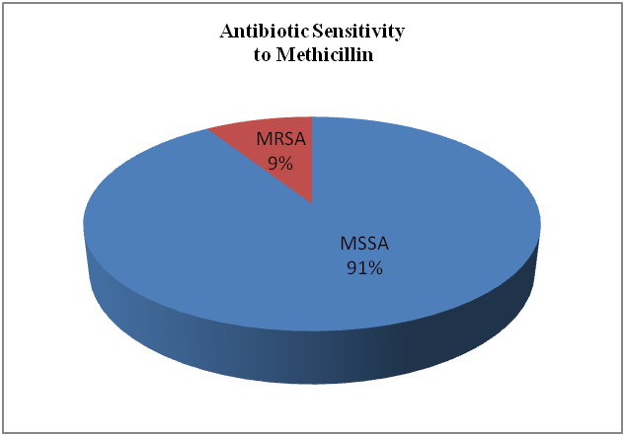

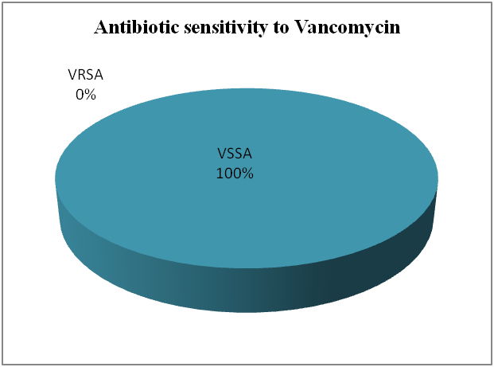

**Fig. Antimicrobial profiles of CPSA isolated from human, livestock and poultry against methicillin and vancomycin.**

**Legend**

MRSA = Methicillin Resistant *Staphylococcus aureus*

MSSA = Methicillin Susceptible *Staphylococcus aureus*

VRSA = Vancomycin Resistant *Staphylococcus aureus*

VSSA = Vancomycin Susceptible *Staphylococcus aureus*

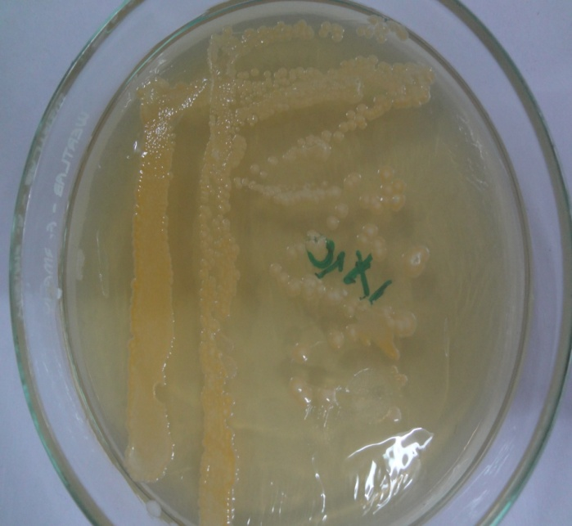 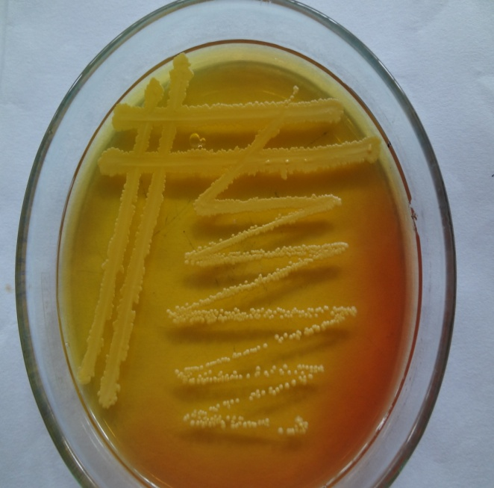

**Fig. 1:** *Staphylococcus aureus* in nutrient agar **Fig. 2:** *Staphylococcus aureus* in MSA

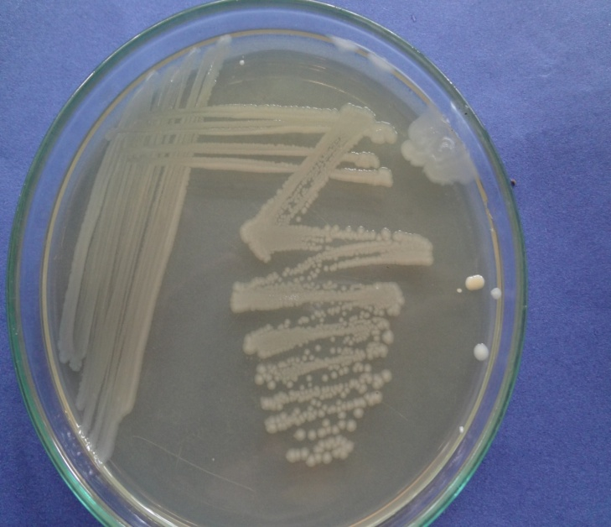 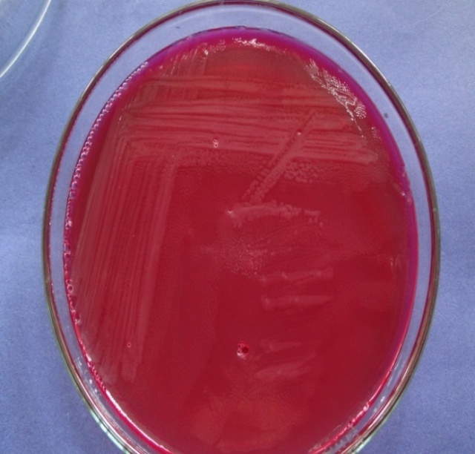

**Fig*.* 3:**Other *Staphylococcus* spp. in nutrient agar **Fig*.* 4:**Other *Staphylococcus* spp. in MSA

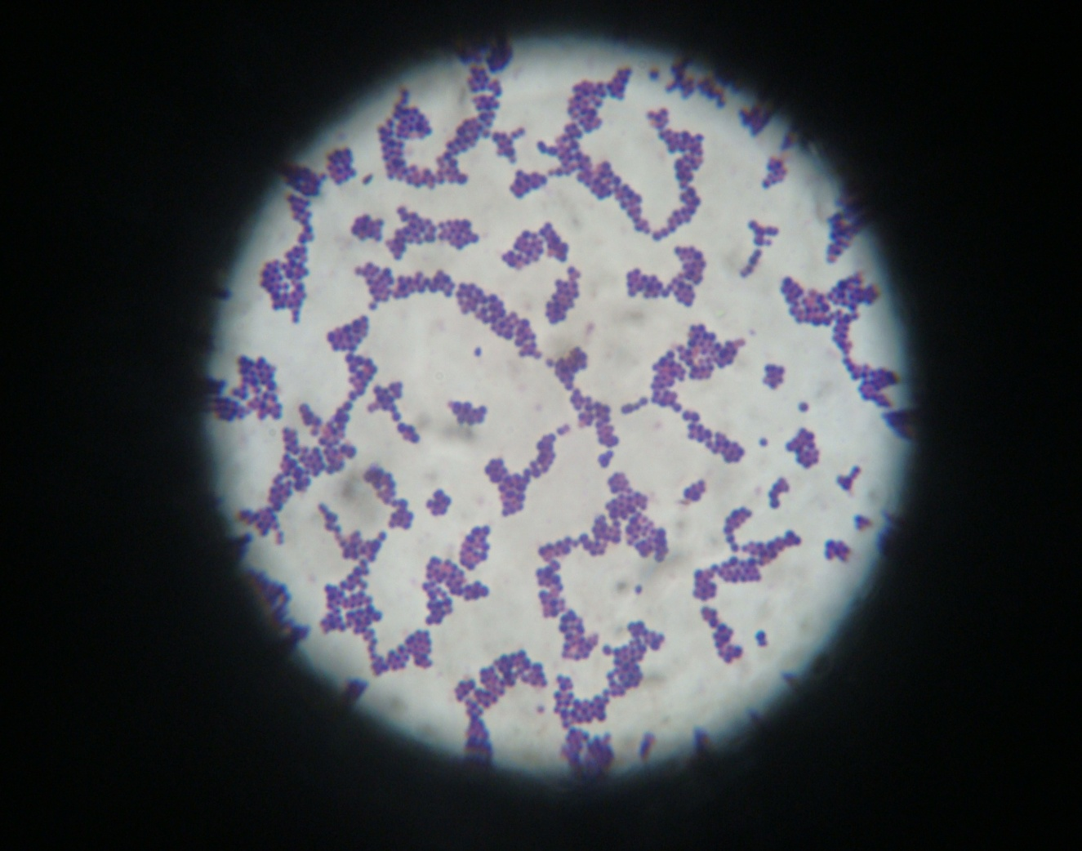

**Fig. 5:** *Staphylococcus* spp. under microscope

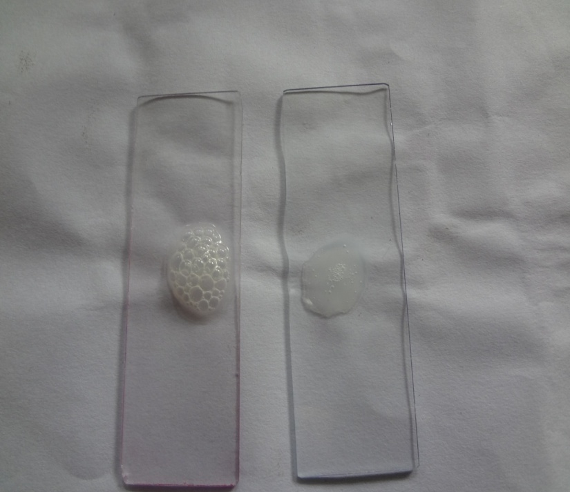

**B**

**A**

**Fig.6:** Catalase test (Slide test). A showing the positive reaction i.e. catalase producing bacteria (*Staphylococcus* spp.) and B indicating the negative reaction.

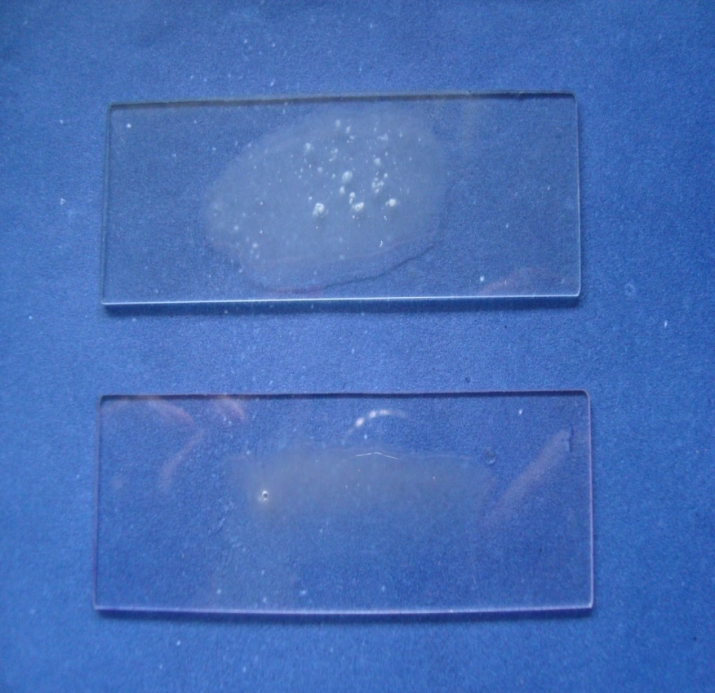

**B**

**A**

**Fig.7:** Coagulase test (Slide test). A showing the positive reaction, card like clot formation. (*Staphylococcus* spp.) and B indicating the negative reaction.

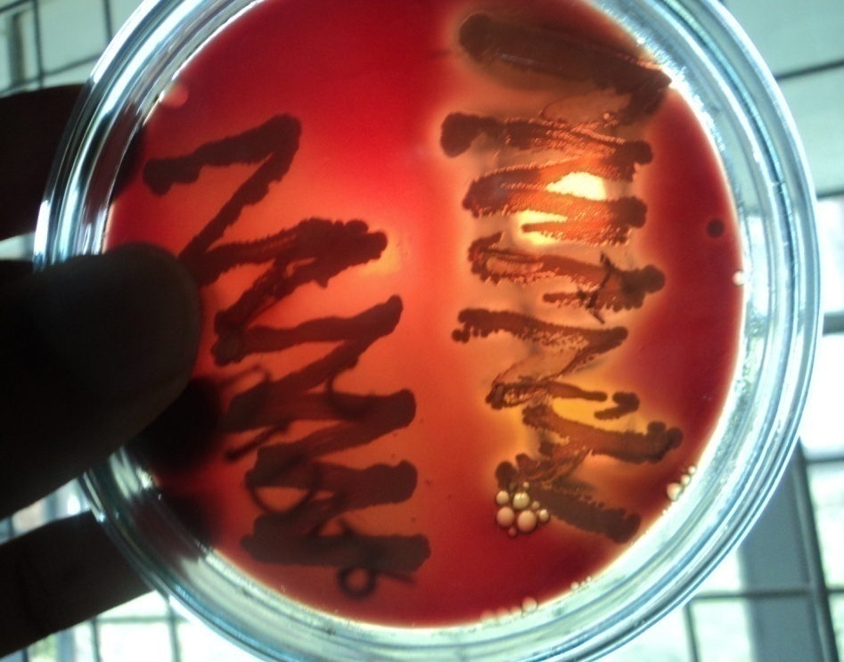

**A**

**B**

**Fig.8:** Coagulase positive *Staphylococcus aureus* on blood agar. A showing the positive reaction (hemolysis) and B indicating the negative reaction (Non-hemolysis).

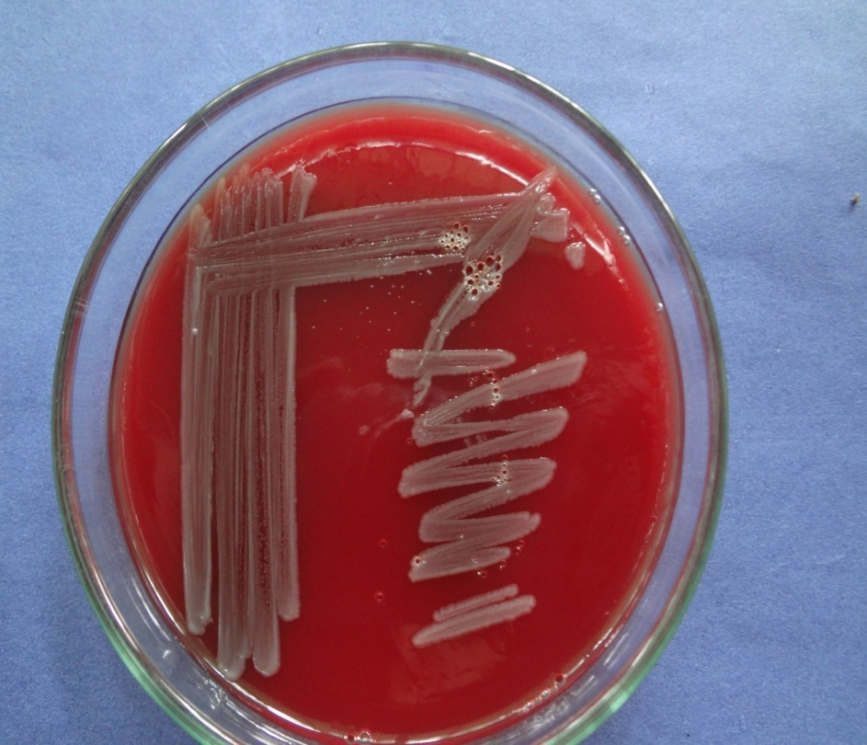

**Fig. 9:** Other *Staphylococcus* spp. on blood agar

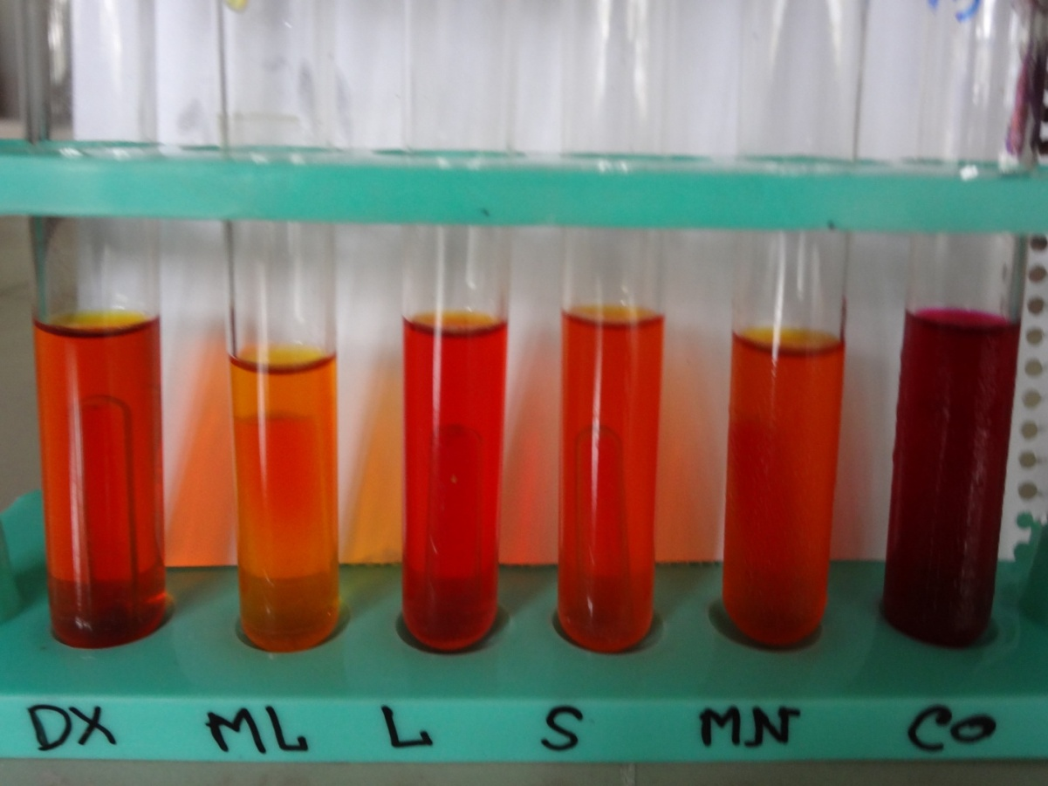

Mannitol

Sucrose

Lactose

Maltose

Dextrose

Control

**Fig. 10:** Sugar Fermentation test. Only acid was produced. No gas was observed in Durham´s tube.

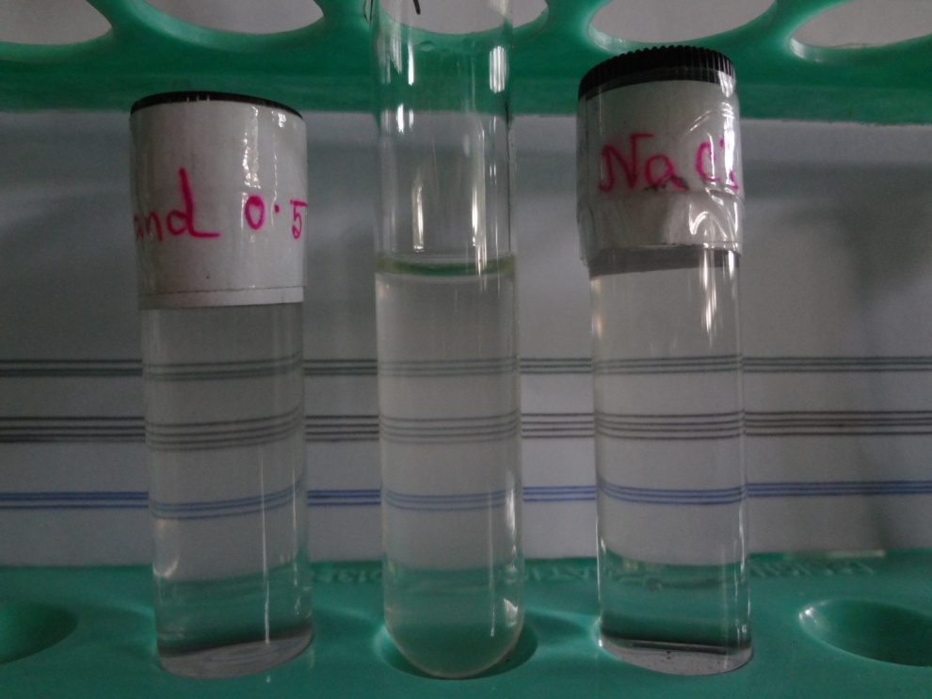

NaCl solution

Sample solution

McFarland standard

**Fig. 11:** 0.5 McFarland standard. Observed the same turbidity between sample solution and McFarland standard.



**Fig. 12:** Spectrophotometer. First observed the standard of NaCl solution.



**Fig.13:** The standard value of sample solution.

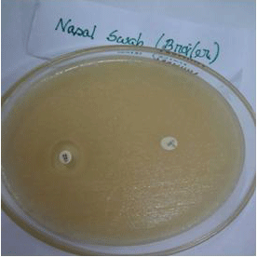

A

B

**Fig. 14a:** Antibiotic sensitivity test in poultry. A (MET) remarks the methicillin resistant and B (VA) remarks the sensitive (17mm) to vancomycin.

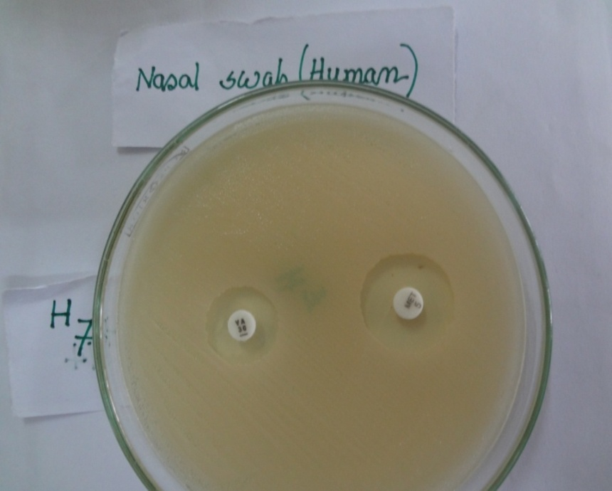

A

B

**Fig. 14b:** Antibiotic sensitivity test in human. A (MET) and B (VA) indicated the methicillin (20mm) and vancomycin (16mm) sensitive respectively.

**CHAPTER 5**

**DISCUSSION**

**CHAPTER 5**

**DISCUSSION**

In the present study *Staphylococcus* spp*.* were isolated from nasal swabs of human (Farm workers and slaughter employees), nasal swab of animals (Cattle and goat), tracheal and cloacal swab of poultry (Broiler and layer), abscess from diseased animals and market meat. Staphylococci are the commensal organism that normally present in the body. According to Das and kanna (1995) the host range of the organism is wide and many strains are potential pathogen.

In this study a total of 100 samples of human, livestock and poultry were examined bacteriologically to find out the presence of CPSA (Coagulase positive *Staphylococcus aureus*) and CNS (Coagulase negative Staphylococci) and to determine their cultural and haemolytic character, antibiotic resistance patterns and detection of MRSA. Out of 100 samples, 58 (58%) were found to be positive. Among them 33 (56.89%) were CPSA and 25 (43.1%) were CNS. The prevalence recorded in this study was in agreement with Das *et al*., (1990) who reported 56.11% prevalence of CPSA.

In the present study out of 30 human specimens 14 *Staphylococcus* isolates were recovered. Of 14 isolates 3 (50%), 2 (40%) and 1 (33.33%) were CPSA which were found in slaughter house employees, cattle farm workers and goat farm workers respectively. The isolation rates recorded in this study were higher than Marcela *et al.,* (2011) and El-Jakee *et al.,* (2008). The difference of rate of prevalence might be due to the small size of samples screened in this experiment. Present study recorded higher prevalence of CPSA in slaughter house employees as compared to others. Data of this study warrant the need for implementation of adequate hygienic and sanitary measures in the slaughter houses.

In case of livestock, this study found 4 (66.67%), 3 (50%) and 2 (40%) CPSA among slaughtered cattle, dairy cattle and goats respectively. Similar rates of isolation were also reported by Anna-Katarina Schillinga *et al*., (2012) and Megra *et al.,* (2006). This study recorded higher rate of isolation of CPSA in slaughter cattle.

In this study 25 of 58 *Staphylococcus* isolates were coagulase negative. The isolation rate of coagulase negative *Staphylococcus* in this study is higher than the rate reported by Alzohairy(2011).

In the present study, the number of CPSA isolates is higher in broiler as compared to layer. This might be due to overcrowding and/or lack of effective sanitary and hygienic measures of the live bird market. The higher isolation rate of CPSA in broiler was also reported by Davy Persoons *et al.,* (2009).

*S. aureus* is one of the important etiological agents responsible for pyogenic infection in man and animals (Rich M., 2005). In case of abscess**,** the rate of isolation of CPSA is higher both in cattle and goats. These results are in agreement with the findings of Menes *et al*., (1984).

In case of market meat CPSA isolates were found both in cattle and goat. Isolation rate of CPSA reported in this study is similar with the isolation rate reported by Branko Podpecan *et al*., (2007). The presence of CPSA in meat sample indicates low hygiene status of market meat and could be a source of transmission of CPSA in humans through food chain.

In this study, the CPSA isolates showed yellow, golden and white chromogenic characteristics**.** Therefore, the production of pigment alone could not be useful for identification of coagulase positive staphylococci. This chromogenic character recorded in this study were found to be similar to the findings of Chatterjee *et al*., (1990) who recorded golden, yellow and white color colonies of CPSA.

In this experiment out of 33 CPSA 25 isolates (75.75%) produced β-hemolysis on BA. Chatterjee *et al*., (1990) found 64.63% β-haemolysis production and Das *et al*., (1990) found 100% β-hemolysis production by the CPSA on 10% sheep blood agar. The variation of rate of hemolysis might be linked to the difference of origin of CPSA isolates.

[

All CPSA isolates in this study fermented glucose, maltose, lactose, sucrose and mannitol fermentation with only acid production. These findings are in close agreement with that of Chatterjee *et al.,* (1990) who reported 81 (98.78%) strains as mannitol fomenters. Hazarika *et al.*, (1995) and Das and Khanna (1994) observed 100% glucose and mannitol fermentation by *S. aureus* strains. A much lower rate of glucose (75.38%) and mannitol (70.76%) fermentation were cuased by *S. aureus* isolated from meat, fish and food handlers (Das and Khanna, 1994).

The antibiotic susceptibility results revealed that all CNS isolates were susceptible to both methicillin and vancomyciin. No resistance was observed against these antibiotics. The findings were in close agreement with Alzohairy(2011). On the other hand 3 of 33 CPSA isolates were found to be resistant to methicillin and rests of the isolates were sensitive. However, All 3 MRSA isolates of this study were sensitive to vancomycin. The antibiotic vancomycin is used to treat MRSA. MiceK (2007) stated that vancomycin remains the reference standard for the treatment of systemic infection caused by methicillin-resistant *Staphylococcus aureus* (MRSA). The findings of this study are in agreement with Kelman *et al.,* (2011) and Persoons *et al.,* (2009). The susceptibility to vancomycin to MRSA was also observed by Sumru Citak *et al*., (2011) and Rhee *et al*., (2010). This study recorded the presence of MRSA in broiler and cattle with abscess. The presence of MRSA in broiler might be resulted from indiscriminate or over use of antibiotics. In 2007, the World Health Organization advised to stop intensive routine use of antimicrobials in food animals (Collignon *et al*., 2009). Data of antibiotic sensitivity profile suggest that MRSA are present on farms, which might be transmitted to animals and humans and would likely to cause serious public and animal health hazard.

In connection of the present study following research works can be done in future:

1. Determination of minimum inhibitory concentration (MIC) of MRSA isolates.
2. Detection of MRSA by PCR.
3. Molecular characterization of MRSA isolates by PCR and sequence analysis.

**CHAPTER 6**

**6ND CONCLUSIONS REFERENCES**

**SUMMARY AND CONCLUSION**

**CHAPTER 6**

**SUMMARY AND CONCLUSION**

The study was conducted on a total of 100 samples of human, livestock and poultry to identify the presence of coagulase positive and negative *Staphylococcus* and to determine their cultural and hemolytic character and antibiotic resistance patterns. The occurrence of CPSA and CNS were 33 (56.89%) and 25 (43.10%) respectively.

Based on colony morphology it was found that the CPSA produced 17 (51.51%) golden yellow, 9 (27.27%) produced yellow and remaining 7 (21.21%) produced white pigment. Among the 33 CPSA 25 (75.75%) produced β-haemolysis on blood agar. No hemolysis was observed in CNS.

Based on antibiotic sensitivity test it was revealed that resistant pattern of the CPSA and CNS differ with methicillin and vancomycin. Three of the CPSA isolates were resistant to methicillin but susceptible to vancomycin. It is important to mention that development of multiple antibiotic resistant CPSA were great alarming for the nation. The result of the present study indicated that vancomycin is the drug of choice for treatment of methicillin-resistant *S. aureus* (MRSA). The use of antimicrobials in production animals has become a worldwide concern in the face of rising resistance levels potentially threatening treatment options in both veterinary and human medicine.

MRSA has entered into farming operations in Bangladesh but still occurring at lower number. This low prevalence suggests that at the moment there is only a limited risk of MRSA transmission from livestock to humans and to food of animal origin. To maintain this situation, further efforts within the field of veterinary public health are of major importance and it is necessary to establish a monitoring system for further trend analysis. Continuous surveillance on resistance patterns of *Staphylococcus* spp.in understanding new and emerging trends is of utmost importance.

**REFFERENCES**

**6ND CONCLUSIONS REFERENCES**

**REFERENCES**

Aarestrup FM. 2005. Veterinary drug usage and antimicrobial resistance in bacteria of animal origin. *Basic & Clin Pharmacol & Toxicol.* 96(4): 271–281.

Abd-Elall AMM, Mohamed MEM and Awadallah MAI. 2009. Potential airborne microbial hazards for workers on dairy and beef cattle farms in Egypt. *Vet. Ital.* 45(2): 275-285.

Acar J and Rostel B. 2001. Antimicrobial resistance: an overview. *Rev Sci Tech.* 20(3): 797-810.

Adegoke GO and Ojo M. 1982. Biochemical characterization of Staphylococci isolated from goats. *Vet Microbiol.* 7(5): 463-470.

Adzitey F, Teye GA, Kutah WN and Adday S. 2011. Microbial quality of beef sold on selected markets in the Tamale Metropolis in the Northern Region of Ghana. [*Livestock Res for Rural Dev.* 23 (1): 23-26.](http://www.lrrd.org/lrrd23/1/cont2301.htm)

Alzohairy MA. 2011. Colonization and antibiotic susceptibility pattern of methicillin resistance *Staphylococcus aureus* (MRSA) among farm animals in Saudi Arabia. *J of Bacteriol.* 3(4): 63-68.

Anna-Katarina Schillinga, Helmut Hotzelb, Ulrich Methnerb, Lisa D, Gernot Schmoockb, Hosny El-Adawyb, Ralf Ehrichtc, Anna-Caroline Wohra, Michael Erharda and Lutz Geued. 2012. Zoonotic Agents in Small Ruminants Kept on City Farms in Southern Germany. *Appl Environ Microbiol*. 78 (11): 3785-3793.

Araujo, ML and Andrioli, JL. 1996. *Staphylococcus aureus:* resistance patterns to antimicrobials and penicillinase among strains isolated from apparently healthy lactating cow. *Revista-de-Microbiol.* 27 (1): 60-63.

Bauer AW and Kirby WMM. 1966. Antibiotic susceptibility testing by a standard single disc method. *Am J Clin Path.* 45(4): 493- 496.

Begier EM, Frenette K, Barrett NL and the Connecticut Bioterrorism Field Epidemiology Response Team. 2004. A high-morbidity outbreak of methicillin-resistant *Staphylococcus aureus* among players on a college football team, facilitated by cosmetic body shaving and turf burns. *Clin Infect Dis*. 39(10): 1446–1453.

Bertolatti D, Hannelly T, Bishop M, French E and Marendoli M. 1996. *Staphylococcus* in Western Australian Poultry. *Int J Environ Health Res.* 6(4): 277-287.

Boyce JM. 2007. Environmental contamination makes an important contribution to hospital infection. *J Hosp Infect.* 65(2): 50-54.

Branko Podpecan, Andrej Pengov and Stanka Vadnjal. 2007. The source of contamination of ground meat for production of meat products with bacteria *Staphylococcus aureus*. *Slov Vet Res*. 44(1/2): 25-30.

Buxton A and Fraser G. 1977*. Animal Microbiology*. *Vol. 1*. Blackwell Scientific Publications, Oxford, London, Edinburg, Melbourne. pp. 400-480.

Carter GR. 1979. *Diagnostic procedure in Veterinary Bacteriology and Mycology*. Charles C. Thomas Publisher*,* USA. 3rd edn. pp. 157-160, 410-411*.*

CDC (Centre for Disease Control and Prevention). 2008. HIV/AIDS in the United States; available at: http://www.cdc.gov/mmwr (accessed 11 July 2011).

Chambers HF. 2001. The changing epidemiology of *Staphylococcus aureus*? *Emerg Infect Dis.* 7(2): 178-182.

[Chatterjee C,](http://www.cabdirect.org/search.html?q=au%3A%22Chatterjee%2C+C.%22) [Nag NC](http://www.cabdirect.org/search.html?q=au%3A%22Nag%2C+N.+C.%22) and [Ray JP.](http://www.cabdirect.org/search.html?q=au%3A%22Ray%2C+J.+P.%22) 1990. Studies on coagulase status and biochemical characters of animal strains of staphylococci. [*Indian J of Anim Heal*](http://www.cabdirect.org/search.html?q=do%3A%22Indian+Journal+of+Animal+Health%22)*th.* 29(2): 157-161.

Cheesebrough M. 1985. Long term preservation of control strains In: *Medical Laboratory Manual for Tropical Countries*. Microbiology II, pp. 400-480.

CLSI (Clinical and Laboratory Standards Institute). 2007. Performance standards for antimicrobials susceptibility testing: 17th informational supplement. CLSI document M100-S17.

Collignon P, Powers JH, Chiller TM, Aidara-Kane A and Aarestrup FM. 2009. World Health Organization ranking of antimicrobials according to their importance in human medicine: A critical step for developing risk management strategies for the use of antimicrobials in food production animals. *Clin Infect Dis.* 49: 132-41.

Cowan ST. 1985. Cowan and Steell´s manual for identification of medical bacteria. 2nd edn. Cambridge University Press, Cambridge, London.

Cuteri V, Marenzoni ML and Mazzolla R. 2004**.** *Staphylococcus aureus*: study of genomic similarity of strains isolated in veterinary pathology using amplified fragment length polymorphism (AFLP)**.** *Comp Immunol Microbiol Infect Dis.* 27(4): 247-53.

Das AK, Panda SN and Kar BC. 1990. Studies on *Staphylococcus aureus* of bovine origin including phase typing. *Indian J of Anim Health.* 29(1): 17-22.

Das SC and Khanna PN. 1994. Biochemical characterization of *Staphylococcus aureus* isolated from food handlers. *Indian J of Anim Health.* 32(2): 115-118.

DasSC and Khanna PN. 1995*.* Antibiogram and phage typ-ing of *Staphylococcus aureus* isolatedfrom meat*,* fish and food handlers. *Indian J. Animal Sci*.65(9): 953-956.

Davy Persoons, Sebastiaan Van Hoorebeke, Katleen Hermans, Patrick Butaye, Aart de Kruif, Freddy Haesebrouck, and Jeroen Dewulf. 2009. Methicillin-Resistant *Staphylococcus aureus* in Poultry. *Emerg Infect Dis*. 15(3): 452 – 453.

de Boer E, Zwartkruis-Nahuis JT, Wit B, Huijsdens XW, de Neeling AJ, Bosch T, van Oosterom RA, Vila A and Heuvelink AE. 2009. Prevalence of methicillin-resistant Staphylococcus aureus in meat. *Int J Food Microbiol.* 134(1-2): 52-56.

Downes FP and Ito K. 2001. Compendium of methods for the microbiological examination of foods. American Public Health Association Press, Washington, D.C.

Doyle MP, Beuchat LR and Montville, TJ. 2001. *Food microbiology*: fundamentals and frontiers. ASM press, Washington, D.C.

El-Jakee J, Nagwa AS, Bakry M, Sahar A, Elgabry ZE and Gad El-Said WA. 2008. Characteristics of *Staphylococcus aureus* strains isolated from human and animal Sources. *J. Agric. & Environ Sci.* 4(2): 221-229.

Ellis MW, Hospenthal DR, Dooley DP, Gray PJ and Murray CK. 2004. Natural history of communityacquired methicillin-resistant *Staphylococcus aureus* colonization and infection in soldiers. *Clin Infect Dis.* 39(7): 971-979.

Ellner, P.D. 1978. Current procedures in Clinical Bacteriology. *Charles C. Thomas, Illinois, USA.* 145-155.

Emikpe BO, Oyero OG and Akpavie SO. 2009. Isolation and Antibiogram of Aerobic Nasal Bacterial Flora of Apparently Healthy West African Dwarf Goats. *Revue Elev Med*  *vet Pays trop*. 62 (1): 17-21.

Eveillard M, Martin Y, Hidri N, Boussougant Y and Joly-Guillou ML. 2004. Carriage of methicillin resistant *Staphylococcus aureus* among hospital employees: prevalence, duration, and transmission to households. *Infect Control Hosp Epidemiol.* 25(2): 114-120.

Farzana, K.; Shah, S.N.H. and Jabeen, F. 2004. Antibiotic resistance pattern against various isolates of Staphylococcus aureus from raw milk samples. *J Res Sci.* 15(4): 145-151.

[Garcia-Graells C](http://www.ncbi.nlm.nih.gov/pubmed?term=Garcia-Graells%20C%5BAuthor%5D&cauthor=true&cauthor_uid=22082716), [Antoine J](http://www.ncbi.nlm.nih.gov/pubmed?term=Antoine%20J%5BAuthor%5D&cauthor=true&cauthor_uid=22082716), [Larsen J](http://www.ncbi.nlm.nih.gov/pubmed?term=Larsen%20J%5BAuthor%5D&cauthor=true&cauthor_uid=22082716), [Catry B](http://www.ncbi.nlm.nih.gov/pubmed?term=Catry%20B%5BAuthor%5D&cauthor=true&cauthor_uid=22082716), [Skov R](http://www.ncbi.nlm.nih.gov/pubmed?term=Skov%20R%5BAuthor%5D&cauthor=true&cauthor_uid=22082716) and [Denis O](http://www.ncbi.nlm.nih.gov/pubmed?term=Denis%20O%5BAuthor%5D&cauthor=true&cauthor_uid=22082716). 2012. Livestock veterinarians at high risk of acquiring methicillin-resistant *Staphylococcus aureus* ST398. [*Epidemiol Infect.*](http://www.ncbi.nlm.nih.gov/pubmed/22082716) 140(3): 383-389.

Geidam YA, Zakaria Z, Aziz SA, Bejo SK, Abu J and Omar S. 2012. High Prevalence of Multi-drug Resistant Bacteria in Selected Poultry Farms in Selangor, Malaysia. *Asian* *J Anim Vet* *Adv.* 7(9): 891-897.

[Gilbert MJ](http://www.ncbi.nlm.nih.gov/pubmed?term=Gilbert%20MJ%5BAuthor%5D&cauthor=true&cauthor_uid=22544853), [Bos ME](http://www.ncbi.nlm.nih.gov/pubmed?term=Bos%20ME%5BAuthor%5D&cauthor=true&cauthor_uid=22544853), [Duim B](http://www.ncbi.nlm.nih.gov/pubmed?term=Duim%20B%5BAuthor%5D&cauthor=true&cauthor_uid=22544853), [Urlings BA](http://www.ncbi.nlm.nih.gov/pubmed?term=Urlings%20BA%5BAuthor%5D&cauthor=true&cauthor_uid=22544853), [Heres L](http://www.ncbi.nlm.nih.gov/pubmed?term=Heres%20L%5BAuthor%5D&cauthor=true&cauthor_uid=22544853), [Wagenaar JA](http://www.ncbi.nlm.nih.gov/pubmed?term=Wagenaar%20JA%5BAuthor%5D&cauthor=true&cauthor_uid=22544853) and [Heederik DJ](http://www.ncbi.nlm.nih.gov/pubmed?term=Heederik%20DJ%5BAuthor%5D&cauthor=true&cauthor_uid=22544853). 2012. Livestock-associated MRSA ST398 carriage in pig slaughterhouse workers related to quantitative environmental exposure. [*Occup Environ Med.*](http://www.ncbi.nlm.nih.gov/pubmed/22544853)69(7): 472-478.

Gorwitz RJ, Kruszon-Moran D, McAllister SK, McQuillan G, McDougal LK, Fosheim GE, Jensen BJ, Killgore G, Tenover FC and Kuehnert MJ. 2008. Changes in the prevalence of nasal colonization with *Staphylococcus aureus* in the United States, 2001-2004*. J Infect Dis.* 197(9): 1226-1234.

[Graveland H](http://www.ncbi.nlm.nih.gov/pubmed?term=Graveland%20H%5BAuthor%5D&cauthor=true&cauthor_uid=21983338), [Duim B](http://www.ncbi.nlm.nih.gov/pubmed?term=Duim%20B%5BAuthor%5D&cauthor=true&cauthor_uid=21983338), [van Duijkeren E](http://www.ncbi.nlm.nih.gov/pubmed?term=van%20Duijkeren%20E%5BAuthor%5D&cauthor=true&cauthor_uid=21983338), [Heederik D](http://www.ncbi.nlm.nih.gov/pubmed?term=Heederik%20D%5BAuthor%5D&cauthor=true&cauthor_uid=21983338) and [Wagenaar JA](http://www.ncbi.nlm.nih.gov/pubmed?term=Wagenaar%20JA%5BAuthor%5D&cauthor=true&cauthor_uid=21983338). 2011. Livestock-associated methicillin-resistant *Staphylococcus aureus* in animals and humans. [*Int J Med Microbiol.*](http://www.ncbi.nlm.nih.gov/pubmed/21983338) 301(8): 630-634.

[Hanning I](http://www.ncbi.nlm.nih.gov/pubmed?term=Hanning%20I%5BAuthor%5D&cauthor=true&cauthor_uid=22221374), [Gilmore D](http://www.ncbi.nlm.nih.gov/pubmed?term=Gilmore%20D%5BAuthor%5D&cauthor=true&cauthor_uid=22221374), [Pendleton S](http://www.ncbi.nlm.nih.gov/pubmed?term=Pendleton%20S%5BAuthor%5D&cauthor=true&cauthor_uid=22221374), [Fleck S](http://www.ncbi.nlm.nih.gov/pubmed?term=Fleck%20S%5BAuthor%5D&cauthor=true&cauthor_uid=22221374), [Clement A](http://www.ncbi.nlm.nih.gov/pubmed?term=Clement%20A%5BAuthor%5D&cauthor=true&cauthor_uid=22221374), [Park SH](http://www.ncbi.nlm.nih.gov/pubmed?term=Park%20SH%5BAuthor%5D&cauthor=true&cauthor_uid=22221374), [Scott E](http://www.ncbi.nlm.nih.gov/pubmed?term=Scott%20E%5BAuthor%5D&cauthor=true&cauthor_uid=22221374) and [Ricke SC](http://www.ncbi.nlm.nih.gov/pubmed?term=Ricke%20SC%5BAuthor%5D&cauthor=true&cauthor_uid=22221374). 2012. Characterization of *Staphylococcus aureus* isolates from retail chicken carcasses and pet workers in Northwest Arkansas. [*J Food Prot*](http://www.ncbi.nlm.nih.gov/pubmed/22221374##). 75(1): 174-178.

[Hanson BM](http://www.ncbi.nlm.nih.gov/pubmed?term=Hanson%20BM%5BAuthor%5D&cauthor=true&cauthor_uid=22000843), [Dressler AE](http://www.ncbi.nlm.nih.gov/pubmed?term=Dressler%20AE%5BAuthor%5D&cauthor=true&cauthor_uid=22000843), [Harper AL](http://www.ncbi.nlm.nih.gov/pubmed?term=Harper%20AL%5BAuthor%5D&cauthor=true&cauthor_uid=22000843), [Scheibel RP](http://www.ncbi.nlm.nih.gov/pubmed?term=Scheibel%20RP%5BAuthor%5D&cauthor=true&cauthor_uid=22000843), [Wardyn SE](http://www.ncbi.nlm.nih.gov/pubmed?term=Wardyn%20SE%5BAuthor%5D&cauthor=true&cauthor_uid=22000843), [Roberts LK](http://www.ncbi.nlm.nih.gov/pubmed?term=Roberts%20LK%5BAuthor%5D&cauthor=true&cauthor_uid=22000843), [Kroeger JS](http://www.ncbi.nlm.nih.gov/pubmed?term=Kroeger%20JS%5BAuthor%5D&cauthor=true&cauthor_uid=22000843) and [Smith TC](http://www.ncbi.nlm.nih.gov/pubmed?term=Smith%20TC%5BAuthor%5D&cauthor=true&cauthor_uid=22000843). 2011. Prevalence of *Staphylococcus aureus* and methicillin resistant *Staphylococcus aureus* (MRSA) on retail meat in Iowa*.* [*J Infect Public Health.*](http://www.ncbi.nlm.nih.gov/pubmed/22000843##) 4(4): 169-74.

Hazarika RA, Mahanta PN and Borah P. 1995. Association of *Staphylococcus aureus* in bovine dermatitis. *Indian J of anim Sci.* 65(6): 629-632

Helen Huber, Dominik Ziegler, Valentin Pflüger, Guido Vogel, Claudio Zweifel and Roger Stephan. 2011. Prevalence and characteristics of methicillin-resistant coagulase-negative staphylococci from livestock, chicken carcasses, bulk tank milk, minced meat, and contact persons*. BMC Vet Res*. 7(1): 6.

Holt JG, Krieg NR, Sneath PHA, Staley JT and Williams ST. 1994. Bergey’s manual of determinative bacteriology. Lippincott Williams & Wilkins, Baltimore, MD. 9th edn, pp. 527-533.

[Hossein Tajik](http://www.researchgate.net/researcher/75833215_Hossein_Tajik), [Mossa Tavassoli](http://www.researchgate.net/researcher/75831638_Mossa_Tavassoli) [Ali Shalizar Jalali](http://www.researchgate.net/researcher/71235147_Ali_Shalizar_Jalali). 2011. Isolated bacteria from subcutaneous abscesses in infested goats with Przhevalskiana species. *Comp Clin Pathol*.14: 13-18

[Huber H](http://www.ncbi.nlm.nih.gov/pubmed?term=Huber%20H%5BAuthor%5D&cauthor=true&cauthor_uid=20430001), [Koller S](http://www.ncbi.nlm.nih.gov/pubmed?term=Koller%20S%5BAuthor%5D&cauthor=true&cauthor_uid=20430001), [Giezendanner N](http://www.ncbi.nlm.nih.gov/pubmed?term=Giezendanner%20N%5BAuthor%5D&cauthor=true&cauthor_uid=20430001), [Stephan R](http://www.ncbi.nlm.nih.gov/pubmed?term=Stephan%20R%5BAuthor%5D&cauthor=true&cauthor_uid=20430001) and [Zweifel C](http://www.ncbi.nlm.nih.gov/pubmed?term=Zweifel%20C%5BAuthor%5D&cauthor=true&cauthor_uid=20430001). 2010. Prevalence and characteristics of meticillin-resistant *Staphylococcus aureus* in humans in contact with farm animals, in livestock, and in food of animal origin, Switzerland. [*Euro Surveill.*](http://www.ncbi.nlm.nih.gov/pubmed/20430001##) 15(16): 19542.

HuebnerJ and Goldmann DA. 1999. Coagulase-negativestaphylococci**:** roleaspathogens. *Annu Rev Med.* 15(1):10-13

Islam MJ, Uddin MS, Islam MA, Nazir KHMNH, Rahman MT and Alam MM. 2007. Detection and characterization of coagulase positive *Staphylococcus aureus* of bovine origin producing enterotoxins and toxic shock syndrome toxin-1. *The Bangladesh veterinarian.* 24(1): 27-33.

Jevons MP, Coe AW and Parker MT. 1963. Methicillin resistance in staphylococci. *Postgrad Med* *J.* 16(3): 268–270.

Juhasz-Kaszanyitzky E, Janosi S, Somogyi P, Adám Dan, Engeline van Duijkeren and Wagenaar AJ. 2007. MRSA Transmission between Cows and Humans. *Emerg Infec Dis*. 139(4): 630-632.

Karsten Becker, Isabelle Pagnier, Brigitte Schuhen, Frauke Wenzelburger, Alexander W. Friedrich, Frank Kipp, Georg Peters, and Christof von. 2006. Does Nasal colonization by Methicillin-Resistant Coagulase-Negative Staphylococci and Methicillin-Susceptible *Staphylococcus aureus* Strains Occur Frequently Enough To Represent a Risk of False-Positive Methicillin-Resistant *S. aureus* Determinations by Molecular Methods? *Eiff. J of clinical microbial.* 44(1): 229–231.

[Kelman A](http://www.ncbi.nlm.nih.gov/pubmed?term=Kelman%20A%5BAuthor%5D&cauthor=true&cauthor_uid=22004808), [Soong YA](http://www.ncbi.nlm.nih.gov/pubmed?term=Soong%20YA%5BAuthor%5D&cauthor=true&cauthor_uid=22004808), [Dupuy N](http://www.ncbi.nlm.nih.gov/pubmed?term=Dupuy%20N%5BAuthor%5D&cauthor=true&cauthor_uid=22004808), [Shafer D](http://www.ncbi.nlm.nih.gov/pubmed?term=Shafer%20D%5BAuthor%5D&cauthor=true&cauthor_uid=22004808), [Richbourg W](http://www.ncbi.nlm.nih.gov/pubmed?term=Richbourg%20W%5BAuthor%5D&cauthor=true&cauthor_uid=22004808), [Johnson K](http://www.ncbi.nlm.nih.gov/pubmed?term=Johnson%20K%5BAuthor%5D&cauthor=true&cauthor_uid=22004808), [Brown T](http://www.ncbi.nlm.nih.gov/pubmed?term=Brown%20T%5BAuthor%5D&cauthor=true&cauthor_uid=22004808), [Kestler E](http://www.ncbi.nlm.nih.gov/pubmed?term=Kestler%20E%5BAuthor%5D&cauthor=true&cauthor_uid=22004808), [Li Y](http://www.ncbi.nlm.nih.gov/pubmed?term=Li%20Y%5BAuthor%5D&cauthor=true&cauthor_uid=22004808), [Zheng J](http://www.ncbi.nlm.nih.gov/pubmed?term=Zheng%20J%5BAuthor%5D&cauthor=true&cauthor_uid=22004808), [McDermott P](http://www.ncbi.nlm.nih.gov/pubmed?term=McDermott%20P%5BAuthor%5D&cauthor=true&cauthor_uid=22004808) and [Meng J](http://www.ncbi.nlm.nih.gov/pubmed?term=Meng%20J%5BAuthor%5D&cauthor=true&cauthor_uid=22004808). 2011. Antimicrobial susceptibility of *Staphylococcus aureus* from retail ground meats*.* [*J Food Prot.*](http://www.ncbi.nlm.nih.gov/pubmed/22004808##) 74(10): 1625-1629.

Kiymet guven, mehmet burcin mutlu, aysel gulbandilar and pinar cakir. 2010. Occurrence and characterization of staphylococcus aureus isolated from meat and dairy products consumed in turkey. *J of food safety.* 30(1): 196–212.

Klevens RM, Morrison MA, Nadle J, Petit S, Gershman K, Ray S, Harrison LH, Lynfield R, Dumyati G, Townes JM, Craig AS, Zell ER, Fosheim GE, McDougal LK, Carey RB and Fridkin SK. 2007. Invasive methicillin-resistant *Staphylococcus aureus* infections in the United States. *J Am Med Assoc.* 298(15):1763-71.

Kluytmans J, van Belkum A and Verbrugh H. 1997. "Nasal carriage of Staphylococcus aureus: epidemiology, underlying mechanisms, and associated risks". *Clin Microbiol Rev*. 10 (3): 505–20.

Kumar P, Shukla I, Varshney S. 2011. Nasal screening of healthcare workers for nasal carriage of coagulase positive MRSA and prevalence of nasal colonization with *Staphylococcus aureus. Bio and Med*. 3(2): 182-186*.*

[Lim SK](http://www.ncbi.nlm.nih.gov/pubmed?term=Lim%20SK%5BAuthor%5D&cauthor=true&cauthor_uid=20467252), [Nam HM](http://www.ncbi.nlm.nih.gov/pubmed?term=Nam%20HM%5BAuthor%5D&cauthor=true&cauthor_uid=20467252), [Park HJ](http://www.ncbi.nlm.nih.gov/pubmed?term=Park%20HJ%5BAuthor%5D&cauthor=true&cauthor_uid=20467252), [Lee HS](http://www.ncbi.nlm.nih.gov/pubmed?term=Lee%20HS%5BAuthor%5D&cauthor=true&cauthor_uid=20467252), [Choi MJ](http://www.ncbi.nlm.nih.gov/pubmed?term=Choi%20MJ%5BAuthor%5D&cauthor=true&cauthor_uid=20467252), [Jung SC](http://www.ncbi.nlm.nih.gov/pubmed?term=Jung%20SC%5BAuthor%5D&cauthor=true&cauthor_uid=20467252), [Lee JY](http://www.ncbi.nlm.nih.gov/pubmed?term=Lee%20JY%5BAuthor%5D&cauthor=true&cauthor_uid=20467252), [Kim YC](http://www.ncbi.nlm.nih.gov/pubmed?term=Kim%20YC%5BAuthor%5D&cauthor=true&cauthor_uid=20467252), [Song SW](http://www.ncbi.nlm.nih.gov/pubmed?term=Song%20SW%5BAuthor%5D&cauthor=true&cauthor_uid=20467252) and [Wee SH](http://www.ncbi.nlm.nih.gov/pubmed?term=Wee%20SH%5BAuthor%5D&cauthor=true&cauthor_uid=20467252). 2010. Prevalence and characterization of methicillin resistant *Staphylococcus aureus* in raw meat in Korea*.* [*J Microbiol Biotechnol.*](http://www.ncbi.nlm.nih.gov/pubmed/20467252##) 20(4): 775-778.

Mack D, Davies A, Harris L, Rohde H, Horstkotte M and Knobloch J. 2007. “Microbial interactions in Staphylococcus epidermidis biofilms”. Analytical and Bioanalytical Chemistry. 387: 399-408.

Madigan M and Martinko J. 2005. *Brock Biology of Microorganisms* (11th ed.). Prentice Hall.

Marcela Vyletelova, Hana Vlkova and Ivan Manga. 2011. Occurrence and Characteristics of Methicillin Resistant *Staphylococcus aureus* and Methicillin Resistant Coagulase-negative Staphylococci in Raw Milk Manufacturing. *Czech J Food Sci*. 29: 11–16.

Megra T, Sisay T and Asseged B. 2006. The Aerobic Bacterial flora of the Respiratory passage ways of healthy goats in Dire Dawa Abattoir, Eastern Ethiopia*. Rev ue Med Vet.* 157(2): 84-87.

[Menes I](http://www.ncbi.nlm.nih.gov/pubmed?term=Menes%20I%5BAuthor%5D&cauthor=true&cauthor_uid=6720145), [Garcia ML](http://www.ncbi.nlm.nih.gov/pubmed?term=Garcia%20ML%5BAuthor%5D&cauthor=true&cauthor_uid=6720145), [Moreno B](http://www.ncbi.nlm.nih.gov/pubmed?term=Moreno%20B%5BAuthor%5D&cauthor=true&cauthor_uid=6720145), [Gutierrez L](http://www.ncbi.nlm.nih.gov/pubmed?term=Gutierrez%20L%5BAuthor%5D&cauthor=true&cauthor_uid=6720145) and [Polledo JJ](http://www.ncbi.nlm.nih.gov/pubmed?term=Polledo%20JJ%5BAuthor%5D&cauthor=true&cauthor_uid=6720145). 1984. Staphylococci isolated from abscesses in slaughtered animals: characterization and epidemiological studies. *Zentralbl Bakteriol Mikrobiol Hyg.*178(5-6): 551-61.

Meyer C, Fredriksson-Ahomaa M, Stüber E, Thiel S, Märtlbauer E. Michael John Male and Tara Smith. 2012. Methicillin-resistant *staphylococcus aureus* (mrsa) in midwestern swine herds and swine workers. *Microbiol.* 122(3-4): 366-372.

Micek ST. 2007. Alternatives to vancomycin for the treatment of methicillin-resistant *Staphylococcus aureus* infections . *Clin. Infect Dis*. 45(3): 184 –190.

Mireille Goetghebeur, Pierre-Alexandre Landry, Donald Han and Colin Vicente 2007. Methicillin-resistant Staphylococcus aureus: A public health issue with economic consequences. *Can J Infect Dis Med Microbiol*. 18(1): 27–34.

Moodley A, Nightingale EC, Stegger M, Nielsen SS, Skov RL and Guardabassi L. 2008. High risk for nasal carriage of methicillin-resistant Staphylococcus aureus among Danish veterinary practitioners. *Scand J Work Environ Health*. 34(2): 151–157.

Morris DO, Mauldin EA, O’Shea K, Shofer FS and Rankin SC. 2006. Clinical, microbiological, and molecular characterization of methicillin-resistant *Staphylococcus aureus* infections of cats. *Am J Vet Res.* 67(8): 1421-1425.

Mubita D, Patel D, Misra DS, Gupta RS and Mule D. 1995. Characterization of Staphylococci from nasal cavity of apparently healthy dogs from Lusaka, Zambia. *Immunol Infect Diseases.* 16(1/2): 46-48.

NCCLS. 2007. Performance Standards for Antimicrbial Susceptibility Testing; Seventeenth Informational Supplement, M100-S17, vol.27. National Committee for Clinical Laboratory Standards, Wayne, PA.

Noskin GA, Rubin RJ, Schentag JJ, Kluytmans J, Hedblom EC, Jacobson C, Smulders M, Gemmen E and Bharmal M. 2007. National trends in *Staphylococcus aureus* infection rates: impact on economic burden and mortality over a 6-year period (1998-2003). *Clin Infect Dis*. 45(9): 1132-1140.

Pinho MG, De Lencastre H, Tomasz A. 2001. An acquired and a native penicillin-binding protein cooperate in building the cell wall of drug-resistant staphylococci. P*roc Natl Acad Sci.* 98(13): 10886-10891.

[Pletinckx LJ](http://www.ncbi.nlm.nih.gov/pubmed?term=Pletinckx%20LJ%5BAuthor%5D&cauthor=true&cauthor_uid=21782977), [Verhegghe M](http://www.ncbi.nlm.nih.gov/pubmed?term=Verhegghe%20M%5BAuthor%5D&cauthor=true&cauthor_uid=21782977), [Dewulf J](http://www.ncbi.nlm.nih.gov/pubmed?term=Dewulf%20J%5BAuthor%5D&cauthor=true&cauthor_uid=21782977), [Crombé F](http://www.ncbi.nlm.nih.gov/pubmed?term=Cromb%C3%A9%20F%5BAuthor%5D&cauthor=true&cauthor_uid=21782977), [De Bleecker Y](http://www.ncbi.nlm.nih.gov/pubmed?term=De%20Bleecker%20Y%5BAuthor%5D&cauthor=true&cauthor_uid=21782977), [Rasschaert G](http://www.ncbi.nlm.nih.gov/pubmed?term=Rasschaert%20G%5BAuthor%5D&cauthor=true&cauthor_uid=21782977), [Goddeeris BM](http://www.ncbi.nlm.nih.gov/pubmed?term=Goddeeris%20BM%5BAuthor%5D&cauthor=true&cauthor_uid=21782977) and [De Man I](http://www.ncbi.nlm.nih.gov/pubmed?term=De%20Man%20I%5BAuthor%5D&cauthor=true&cauthor_uid=21782977). (2011). Screening of poultry-pig farms for methicillin-resistant *Staphylococcus aureus*: sampling methodology and within herd prevalence in broiler flocks and pigs. [*Infect Genet Evol.*](http://www.ncbi.nlm.nih.gov/pubmed/21782977) 11(8): 2133-2137.

Quinn PJ, Markey BK, Carter ME, Donnelly WJ and Leonard C. 2002. Veterinary Microbiology and Microbial disease. Blackwell Sciences Ltd Oxford, United Kingdom.

[Rhee CH](http://www.ncbi.nlm.nih.gov/pubmed?term=Rhee%20CH%5BAuthor%5D&cauthor=true&cauthor_uid=21219750) and [Woo GJ](http://www.ncbi.nlm.nih.gov/pubmed?term=Woo%20GJ%5BAuthor%5D&cauthor=true&cauthor_uid=21219750). 2010. Emergence and characterization of foodborne methicillin-resistant *Staphylococcus aureus* in Korea*.* [*J Food Prot.*](http://www.ncbi.nlm.nih.gov/pubmed/21219750##) 73(12): 2285-90.

[Rich M](http://www.ncbi.nlm.nih.gov/pubmed?term=Rich%20M%5BAuthor%5D&cauthor=true&cauthor_uid=15997888). 2005. Staphylococci in animals: prevalence, identification and antimicrobial susceptibility, with an emphasis on methicillin-resistant *Staphylococcus aureus*. [*Br J Biomed Sci.*](http://www.ncbi.nlm.nih.gov/pubmed/15997888)62(2): 98-105.

[Rodgers JD](http://www.ncbi.nlm.nih.gov/entrez/query.fcgi?db=pubmed&cmd=Search&itool=pubmed_Abstract&term=%22Rodgers+JD%22%5BAuthor%5D), [McCullagh JJ](http://www.ncbi.nlm.nih.gov/entrez/query.fcgi?db=pubmed&cmd=Search&itool=pubmed_Abstract&term=%22McCullagh+JJ%22%5BAuthor%5D), [McNamee PT](http://www.ncbi.nlm.nih.gov/entrez/query.fcgi?db=pubmed&cmd=Search&itool=pubmed_Abstract&term=%22McNamee+PT%22%5BAuthor%5D), [Smyth JA](http://www.ncbi.nlm.nih.gov/entrez/query.fcgi?db=pubmed&cmd=Search&itool=pubmed_Abstract&term=%22Smyth+JA%22%5BAuthor%5D) and [Ball HJ](http://www.ncbi.nlm.nih.gov/entrez/query.fcgi?db=pubmed&cmd=Search&itool=pubmed_Abstract&term=%22Ball+HJ%22%5BAuthor%5D). 1999. Comparison of *Staphylococcus aureus* recovered from personnel in a poultry hatchery and in broiler parent farms with those isolated from skeletal disease in broilers. [*Vet Microbiol.*](javascript:AL_get(this,%20'jour',%20'Vet%20Microbiol.');) 69(3): 189-198.

Rodolpho D, Marin JM and Araujo MLC.2006. Antimicrobial drug resistance of *staphylococcus spp.* isolated from healthy lactating cows of an organic farm *.Ars Veterinaria Jaboticabal.* 22(1):037-042*.*

Ryan KJ and Ray CG. 2004. *Sherris Medical Microbiology* (4th edn.). McGraw Hill. ISBN 0-8385-8529-9.

Saitoh Y, Shimizu A, Yagi M, Adachi T, Kawano J, Hikami Y, Gohda M and Sukigara S. 1994. Characteristics of *Staphylococcus aureus* isolated from healthy and diseased chickens. *Science reports of Faculty of Agriculture, Kobe University.* 21(1): 1-9.

Saleha AA and Zunit Z. 2010. Methicillin Resistant *Staphylococcus aureus* (MRSA): An Emergingg Veterinary and Zoonotic Pathogen of Public Health concern and Some Studies in Malaysia.

[Samar S,](http://www.springerlink.com/content/?Author=Samar+S.+Quddoumi) [Salwa QM, Bdour](http://www.springerlink.com/content/?Author=Salwa+M.+Bdour) and [Mahasneh](http://www.springerlink.com/content/?Author=Adel+M.+Mahasneh) AM. 2006. [Isolation and characterization of methicillin-resistant *Staphylococcus aureus* from livestock and poultry meat](http://www.springerlink.com/content/l552375u24101qwj/). [*Biomed and Life Sci*](http://www.springerlink.com/biomedical-and-life-sciences/)[*Ann of Microbiol*](http://www.springerlink.com/content/1590-4261/)*.* [56(2](http://www.springerlink.com/content/1590-4261/56/2/" \o "Link to the Issue of this Article)): 155-161.

Scanvic A, Denic L, Gaillon S, Giry P, Andremont A and Lucet JC. 2001. Duration of colonization by methicillin-resistant *Staphylococcus aureus* after hospital discharge and risk factors for prolonged carriage. *Clin Infect Dis.* 32: 1393-1398.

Silva MAR, Higino JS, Pereira JV, Siqueira-Júnior Jp, Maria and Pereira SV. 2008.Antibiotic activity of the extract of *Punica granatum* Linn. over bovine strains of *Staphylococcus aureus. Brazilian J of Pharmaco*. 18(2): 209-212.

Shittu OA and Lin J. 2006. Antimicrobial susceptibility patterns and characterization of clinical isolates of *Staphylococcus aureus* in KwaZulu-Natal province, South Africa. *BMC* *Infect Dis*. 6: 125.

Sumru Citak and Tugba Duman. 2011. *Staphylococcus aureus* and coagulase-negative *Staphylococcus* from raw chicken samples in Turkey: Prevalence and antimicrobial resistance *J Food, Agri & Environ*. 9(1): 156 – 158.

Takahashi T, Satoh I and Kikuchi N. 1999. "Phylogenetic relationships of 38 taxa of the genus *Staphylococcus* based on 16S rRNA gene sequence analysis". *Int. J. Syst. Bacteriol*. 49 (2): 725–728.

Takeshige K and Ilida T. 1997. Detection of *Staphylococcus aureus* in a slaughter house and characterization of isolates. *J of the Japan Vet Med Res* 50 (1): 45-47**.**

Tenover FC and McGowan JE Jr. 1996. Reasons for the emergence of antibiotic resistance. *Am J Med Sci.* 311(1): 9-16.

Vanderhaeghen W, Hermans K, Haesebrouck F, Butaye P. 2010. Methicillin-resistant *Staphylococcus aureus* (MRSA) in food production animals. *Epidemiol Infect*. 138 (5): 606-625.

Vautor E, Abadie G, Guibert J-M, Chevalier N, Pepin M. 2004. Nasal carriage of *Staphylococcus aureus* in dairy sheep. AFSSA (Agence Française de Securite Sanitaire des Aliments), Unite de Pathologie des Petits Ruminants, BP111, 06902 Sophia-Antipolis Cedex, France.

Voss A, Loeffen F, Bakker J, Klaassen C, Wulf M (2005). Methicillin-resistant *Staphylococcus aureus* in pig farming. *Emerg Infect Dis.* 11: 1965-1966.

Wassenaar TM. 2005. Use of antimicrobial agents in veterinary medicine and implications for human health. *Crit Rev Microbiol.* 31(3): 155-69.

[Weese](http://www.ncbi.nlm.nih.gov/sites/entrez?cmd=search&db=PubMed&term=%20Weese%2BJS%5bauth%5d) JS, [Reid-Smith](http://www.ncbi.nlm.nih.gov/sites/entrez?cmd=search&db=PubMed&term=%20Reid-Smith%2BR%5bauth%5d) R, [Rousseau](http://www.ncbi.nlm.nih.gov/sites/entrez?cmd=search&db=PubMed&term=%20Rousseau%2BJ%5bauth%5d) J and [Brent Avery](http://www.ncbi.nlm.nih.gov/sites/entrez?cmd=search&db=PubMed&term=%20Avery%2BB%5bauth%5d). 2010. Methicillin-resistant *Staphylococcus aureus* (MRSA) contamination of retail pork . *Can Vet J.* 51(7): 749–752.

[White DG](http://www.ncbi.nlm.nih.gov/pubmed?term=White%20DG%5BAuthor%5D&cauthor=true&cauthor_uid=12713179), [Ayers S](http://www.ncbi.nlm.nih.gov/pubmed?term=Ayers%20S%5BAuthor%5D&cauthor=true&cauthor_uid=12713179), [Maurer JJ](http://www.ncbi.nlm.nih.gov/pubmed?term=Maurer%20JJ%5BAuthor%5D&cauthor=true&cauthor_uid=12713179), [Thayer SG](http://www.ncbi.nlm.nih.gov/pubmed?term=Thayer%20SG%5BAuthor%5D&cauthor=true&cauthor_uid=12713179) and [Hofacre C](http://www.ncbi.nlm.nih.gov/pubmed?term=Hofacre%20C%5BAuthor%5D&cauthor=true&cauthor_uid=12713179). 2003. Antimicrobial susceptibilities of *Staphylococcus aureus* isolated from commercial broilers in northeastern Georgia, *Avian Dis.* 47(1): 203-210.

WHO. 2000. Antimicrobial resistance is an unusual public health threat.*J. antimicrob chemother.* 12: 122-131.